POCKETSMART AI
AI Assistant for Smarter Budget Planning and Shopping Support

PROJECT REPORT

Team Members
Adhisayam P
Aiswarya R
Benjamin M
Bharath S
Chandru R

Department / Institution: ______________________________
Academic Year: ______________________________

ABSTRACT
PocketSmart AI is an AI-powered budget planning platform designed to simplify planning for home interiors, parties, and jewelry purchases. Users provide a budget and relevant preferences, and the application generates organized budget breakdowns, shopping lists, platform suggestions, and personalized recommendations.
The backend is developed using Python and FastAPI with a RESTful architecture. SQLite is used for data storage, while SQLAlchemy supports database interaction and data modeling. JWT-based authentication protects user-specific features, and bcrypt is used to hash passwords. Integration with the Google Gemini API enables dynamic generation of planning content. The platform aims to reduce repetitive manual calculations and help users organize decisions in one place.

CONTENTS
1. Introduction
2. System Analysis
3. System Requirements
4. System Design
5. Implementation
6. Testing and Validation
7. Conclusion and Future Enhancements
Appendix A: API Testing Checklist
Appendix B: Application Execution Screenshot

1. INTRODUCTION

1.1 Project Overview
PocketSmart AI brings budget planning and shopping support together in a single application. It provides three planning areas: Home, Party, and Jewelry. A user can enter a budget and planning details, then request AI-generated suggestions suited to the submitted information.

1.2 Objectives
- Provide a centralized interface for home, party, and jewelry planning.
- Generate budget breakdowns and shopping suggestions using generative AI.
- Support secure registration and login with token-based authentication.
- Save plan information so users can revisit recent plans.
- Use a modular backend that can be maintained and extended.

1.3 Scope
The project focuses on generating planning content and organizing saved plans. Recommendations are informational and should be verified against current vendor prices, availability, and individual requirements. Unless a live shopping integration is implemented, platform names and prices are suggestions rather than verified real-time offers.

2. SYSTEM ANALYSIS

2.1 Existing System
Traditional planning often involves checking several websites or applications, calculating costs manually, and keeping notes in separate places. This can make it difficult to compare options, maintain a clear budget, and retrieve earlier planning decisions.

2.2 Proposed System
PocketSmart AI provides a centralized application where authenticated users select a planner, submit their budget and preferences, and receive AI-generated planning content. Plans can be stored and viewed later through the history feature.

2.3 Scenario-Based Case Study
Priya is organizing a party for 100 guests with a budget of ₹50,000. She needs to account for venue, catering, decoration, and cake expenses. She may also be furnishing a home or choosing jewelry to match an outfit. PocketSmart AI helps organize these requirements and generate a starting breakdown or recommendation list.

2.4 Problem Statement
- Manual expense calculations take time and can be error-prone.
- Comparing products and services across multiple platforms is repetitive.
- Users may find it difficult to allocate a fixed budget across several expense categories.
- Personalized jewelry suggestions require considering outfit, occasion, and budget.
- Planning details may be scattered and difficult to retrieve later.

3. SYSTEM REQUIREMENTS

3.1 Software Requirements
- Operating system: Windows 10/11, macOS, or Linux.
- Python 3.10 or later (the development environment shown uses Python 3.13).
- FastAPI and Uvicorn for the backend server.
- SQLite database and SQLAlchemy ORM.
- JWT and bcrypt-related packages for authentication and password hashing.
- Google Gemini API access and an API key configured securely in environment variables.
- Visual Studio Code or another suitable code editor.
- Postman or an equivalent HTTP client for API testing.

3.2 Hardware Requirements
- Processor: Intel Core i5 / AMD Ryzen 5 or equivalent.
- RAM: 8 GB minimum; 16 GB recommended for development multitasking.
- Storage: at least 1 GB of available workspace, excluding optional development tools.

3.3 User Roles
User: registers, logs in, creates and views plans, accesses planner features, and reviews saved history. Administrative functions should be included only if they are implemented and protected in the actual application.

4. SYSTEM DESIGN

4.1 System Architecture
The application follows a client-server design. The browser-based frontend sends requests to the FastAPI backend. Route handlers validate input and authentication, call application logic, interact with the database through SQLAlchemy, and call the Gemini service when AI-generated content is required.
Frontend (HTML/CSS/JavaScript templates)
↓ HTTP requests
FastAPI routes and request validation
↓
Authentication and application logic
↙ ↘
SQLite via SQLAlchemy Gemini API service
↓ ↓
Saved plans / response returned to frontend

4.2 Main Components
- Client application: pages for registration, login, dashboard, and the three planners.
- FastAPI server: receives requests and returns responses or rendered pages.
- Authentication: checks user identity and protects private operations.
- Route handlers: coordinate authentication, plan operations, and AI features.
- AI service: sends prompts to Gemini and processes generated responses.
- Database layer: stores user and plan data using SQLite and SQLAlchemy.

4.3 Database Design and ER Description
The shared project description identifies two main data entities: User and Plan. Confirm the exact table and field names against the final models.py/database implementation before submission.

User entity
- id — primary key
- name — registered user name
- email — unique user email
- password — securely hashed password
- created_at / updated_at — timestamps, if implemented

Plan entity
- id — primary key
- user_id — foreign key referencing User
- plan_type — party, home, or jewelry
- budget — planned amount
- details — plan inputs and generated content, depending on implementation
- created_at / updated_at — timestamps, if implemented
Relationship: one User can own multiple Plans (one-to-many). Party breakdowns, home shopping items, jewelry suggestions, and history may be stored as fields or structured data within a plan, depending on the actual implementation. Do not represent them as separate database tables unless those tables exist in the code.

4.4 User Flow
- User registers or logs in.
- The application validates the user's session or token.
- The user opens the dashboard and selects Home, Party, or Jewelry.
- The user enters a budget and relevant planning details.
- The backend validates the request and invokes the relevant planning logic or Gemini service.
- The generated result is returned and, where supported, saved for later viewing.
- The user can open the history page to review saved plans.

4.5 Security Design
- Use JWT or the implemented session mechanism to protect private routes.
- Hash passwords with bcrypt; never store plaintext passwords.
- Keep API keys in environment variables and do not commit them to source control.
- Validate request data and uploaded files before processing.
- Ensure users can access only their own private plans.

5. IMPLEMENTATION

5.1 Technology Stack
Python, FastAPI, Uvicorn, SQLite, SQLAlchemy, HTML templates, and Google Gemini API are identified in the supplied project description. The precise installed package versions and actual module names should be taken from requirements.txt and the source code.

5.2 Main Modules
- main.py: application entry point, routes, and page handling.
- Database module: database connection and session configuration.
- Models: user and plan data models.
- Authentication logic: registration, login, password hashing, and access checks.
- Gemini service: prompt construction and AI response handling.
- Templates: dashboard, history, home planner, party planner, jewelry planner, login, and registration pages.

5.3 Planner Features

Party Planner
Accepts party requirements such as budget and guest count and generates a proposed allocation across expense categories. The supplied example uses a ₹50,000 budget for 100 guests, with illustrative allocations of venue ₹7,000, catering ₹30,000, decoration ₹4,000, and cake ₹3,000. These figures total ₹44,000, leaving ₹6,000 unallocated; the report should clarify whether that remainder is intentional or reserved for other costs.

Home Planner
Generates a proposed home-interior shopping list based on budget and room or style preferences. Platform suggestions may include Amazon, IKEA, and Pepperfry. Prices and stock should be checked directly with vendors.

Jewelry Planner
Generates jewelry-matching suggestions based on information such as outfit, occasion, and budget. If image upload is supported by the final code, document the accepted file types, size limits, and image-processing behavior based on implementation.

5.4 Running the Application
Typical local setup commands, subject to the project's actual requirements:
python -m venv venv
venv\Scripts\activate
pip install -r requirements.txt
uvicorn main:app --reload
When the server starts successfully, the development server may be available at http://127.0.0.1:8000. Keep secrets such as the Gemini API key in a local environment file and exclude that file from shared submissions.

6. TESTING AND VALIDATION
API testing should verify both successful requests and expected error responses. The following checklist is a suggested test plan; mark results only after running the tests against the actual application.
Test case | Method / route (confirm in code) | Expected result | Status
User registration | POST /register | Valid user is created; invalid or duplicate data is rejected | To test
User login | POST /login | Valid credentials authenticate; invalid credentials are rejected | To test
Party generation | Party generation route | Authenticated request returns a party breakdown | To test
Home generation | Home generation route | Authenticated request returns a shopping list | To test
Jewelry generation | Jewelry generation route | Valid request returns matching suggestions | To test
Plan history | GET /history or implemented equivalent | User sees their saved plans | To test
Unauthorized access | Protected route without valid authentication | Request is denied or redirected as designed | To test
Plan deletion | Implemented DELETE route, if available | Authorized owner can delete the selected plan | To test
The exact endpoint paths, HTTP methods, request fields, response formats, and test outcomes must be verified using the running application or its API documentation. Do not treat illustrative routes in planning notes as confirmed endpoints.

7. CONCLUSION AND FUTURE ENHANCEMENTS
PocketSmart AI demonstrates how a web application can combine structured budget planning with generative AI. Its Home, Party, and Jewelry planners aim to reduce repetitive planning work, while authentication and saved-plan functionality help users organize their information.
Possible future enhancements include live price and availability integrations, exportable budgets, spending alerts, additional planner categories such as travel and weddings, improved validation of AI-generated totals, and more detailed reporting. Any future work should preserve user privacy and clearly distinguish generated estimates from verified prices.

APPENDIX A: API TESTING CHECKLIST
Use the application's actual API documentation (for example, the FastAPI /docs page, if enabled) or the Postman collection to record endpoint paths, request examples, response codes, and screenshots. Replace the suggested routes in Chapter 6 with verified routes before final submission.

APPENDIX B: APPLICATION EXECUTION SCREENSHOT
Insert the supplied VS Code screenshot here as evidence of local execution. The screenshot shows the PocketSmart-Final project, the main.py file, HTML templates, and Uvicorn starting at http://127.0.0.1:8000.
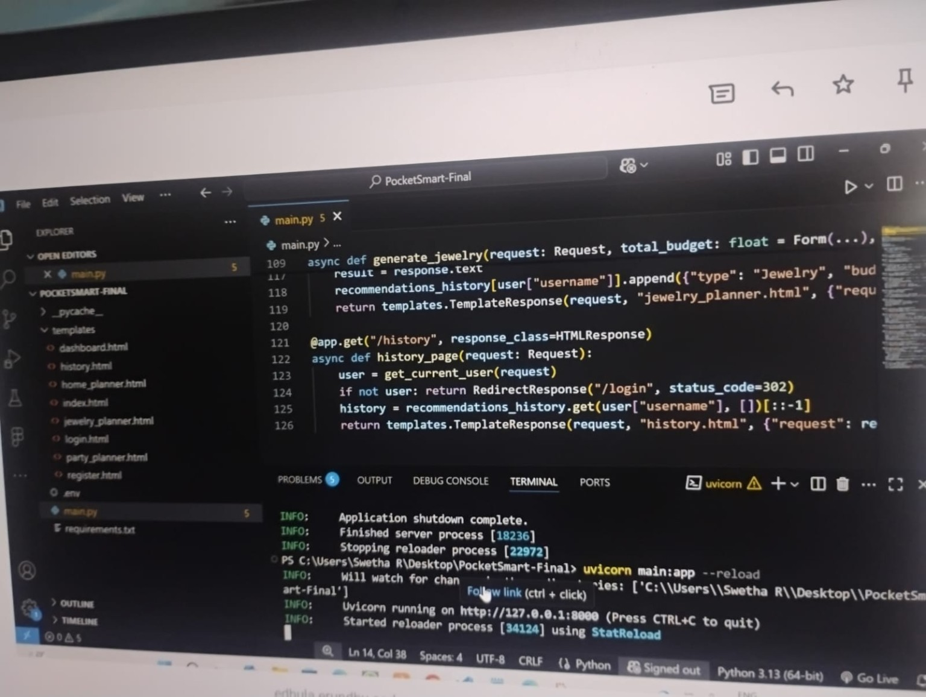

APPENDIX C: PROJECT LINKS
Project source code (Google Drive): https://drive.google.com/drive/folders/1PLE1uyWnuz1hYDHGjwPetAecrfMOxdXb?usp=sharing

API testing link (Google Drive): https://drive.google.com/drive/u/0/folders/1IzQZklPEjG23R7cMqEYC_o7JgJmJcsCe

Demo Drive Link (Google Drive): https://drive.google.com/drive/u/0/folders/1IzQZklPEjG23R7cMqEYC_o7JgJmJcsCe

